Experiment done in 2013.10.25

# Goal:

server can contact each other using l3 interface.

Ip dst/src modification can work in the above scenario.

# Datacenter and experiment configuration:

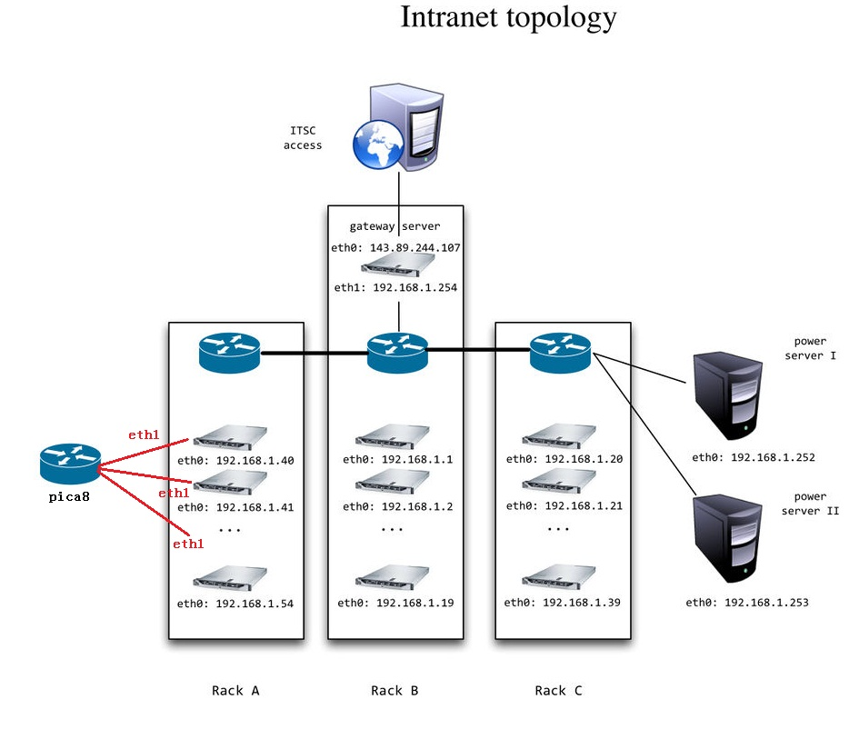

We add a pica8 switch to the servers in Rack A.

We use eth1 of each rack server and set eth1 addr 192.168.2.* to communicate via the pica8 switch.

Followings are the details:

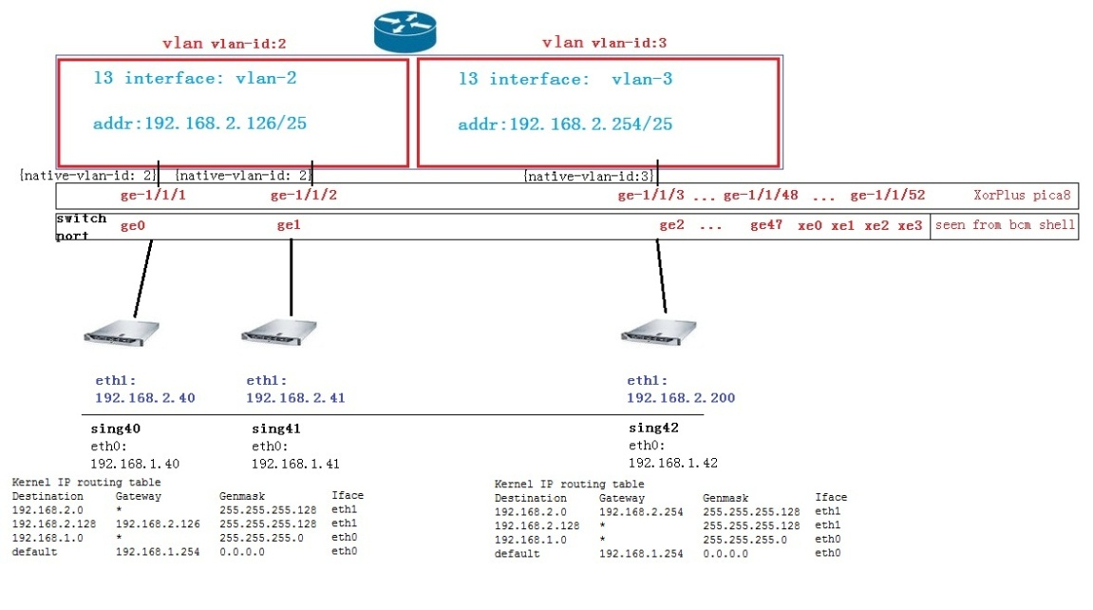

# Configure Code:

XorPlus# set vlans vlan-id 2 %declear a vlan with vlan-id=2

[edit]

XorPlus# set vlans vlan-id 3 %declear a vlan with vlan-id=3

[edit]

XorPlus# set interface gigabit-ethernet ge-1/1/1 family ethernet-switching native-vlan-id 2 %ge-1/1/1 is in vlan-id=2

[edit]

XorPlus# set interface gigabit-ethernet ge-1/1/2 family ethernet-switching native-vlan-id 2 %ge-1/1/2 is in vlan-id=2

[edit]

XorPlus# set interface gigabit-ethernet ge-1/1/3 family ethernet-switching native-vlan-id 3 %ge-1/1/3 is in vlan-id=3

[edit]

XorPlus# set vlans vlan-id 2 l3-interface vlan-2 %set vlan 2 a l3-intf named vlan-2

[edit]

XorPlus# set vlans vlan-id 3 l3-interface vlan-3 %set vlan 3 a l3-intf named vlan-3

[edit]

XorPlus# commit

Waiting for merging configuration.

Commit OK.

Save done.

[edit]

XorPlus# set vlan-interface interface vlan-2 vif vlan-2 address 192.168.2.126 prefix-length 25 %set l3 intf ip and mask

[edit]

XorPlus# set vlan-interface interface vlan-3 vif vlan-3 address 192.168.2.254 prefix-length 25 %set l3 intf ip and mask

[edit] XorPlus# commit

Waiting for merging configuration.

Commit OK.

Save done.

## Results and Explanations:

1. Without configuring switch: (L2 switch): 192.168.2.40 can ping 192.168.2.41 cannot reach 192.168.2.200. IP modification code works in 192.168.2.40<-> 192.168.2.41
2. After configuring switch: (l3 switch) 192.168.2.40 traceroute 192.168.2.41: 1 hop. 192.168.2.40 can traceroute 192.168.2.200: 2 hops. Use tcpdump –i eth1, we can see the IP modification code works for 40<->41. 40 cannot reach 200 because of arp.
3. Farpd 192.168.2.X 192.168.2.X+20. IP modification works for 40<->200.